## Historical data and journal milestones

* + Historically, *Psychophysiology* published 768 pages per volume (**six 128-page issues**). In 2002, 960 pages were allocated to alleviate backlogs for printing.
  + The contract with Blackwell (then Wiley-Blackwell, and now Wiley) Publishing began in **2003** and provided for 1020 pages annually.
  + A shortened editorial lag that began when Margaret Bradley instituted email submission and review in 2003. Previous Editors handled manuscripts via regular mail.
  + Beginning **January 1, 2006**, *Psychophysiology,* with the support of Blackwell Publishing (later bought by Wiley), adopted ScholarOne’s Manuscript Central as its submission and review system.
  + In **January 2011** Psychophysiology started publishing 12 (monthly) issues per year, to resolve backlog. Since printing was involved, page numbers needed to be tracked.
    - These changes had an impact on submissions. The introduction of MC quickly increase yearly submissions from about 200 to about 400
  + Beginning **January 1, 2015,** *Psychophysiology* ended its printed version and became an on-line only journal, which allowed the free publications of color pictures and freedom from page counts.
    - Journal submissions started growing and nearly doubled again from about 400 to >700.
    - In 2016 the journal cover was changed to one that could be easily used as an on-line icon.

## Trend tables from 2006-2014

**Table 2. Manuscript content**

|  |  |  |  |  |  |
| --- | --- | --- | --- | --- | --- |
|  | **2014** | 2013 | 2012 | 2011 | 2010 |
| **MEASURES** |  |  |  |  |  |
| ERP/EEG/MEG/fMRI | **66%** | 58% | 66% | 61% | 57% |
| Cardiovascular | **26%** | 19% | 14% | 15% | 22% |
| EMG/Startle | **8%** | 8% | 10% | 9% | 9% |
| EDA | **9%** | 8% | 8% | 7% | 10% |
| **Other (Respiration, pupil, biochem, etc.)** | **18%** | 10% | 9% | 15% | 15% |
|  | | | | | |
| **CONTENT** |  |  |  |  |  |
| Cognition/Attention/S&P/Language | **81%** | 46% | 59% | 59% | 60% |
| Emotion/Motivation | **38%** | 30% | 24% | 33% | 32% |
| Indiv. Diff/ Psychopathology | **25%** | 30% | 23% | 23% | 32% |
| BehMed/Stress/Pain/Biofeedback | **12%** | 11% | 11% | 9% | 8% |
| Learning/Conditioning | **3%** | 11% | 17% | 12% | 14% |
| **Other (Social, Genetics, Sleep, etc.)** | **18%** | 16% | 13% | 11% | 13% |

## 

**2015**



**2016**



**2017**



**2018**



**2019**

**2020**

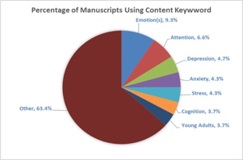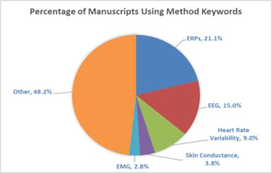

**2021**

**2022**

